Group 3 Final Project Completed by:

Farhana Afroz 219996974
Furqan Azmat 219662717
Ayaz Bhutta 220677381
Matthew Clarke 211128360
Sarah Dakakni 219538974

Data Description

Our dataset was sourced from a Portuguese bank, containing data for over 40000 clients. It includes detailed personal information, how the bank has marketed toward the client, and macro-economic data relating to the period in which the client received marketing communications. It contains 4 individual datasets:

- Bank Additional Full contains 41188 tuples and 20 attributes including detailed client data and macroeconomic data

- Bank Additional contains 10% of the Bank Additional Full tuples randomly selected, with all attributes, specifically created for use with demanding machine learning algorithms

- Bank Full is an older version of the dataset that contains over 45000 tuples with detailed personal information, but no macroeconomic information

- Bank contains 10% of the Bank Full tuples randomly selected, with all attributes, specifically created for use with demanding machine learning algorithms

For our classification project we almost exclusively used Bank Additional Full.

Exploratory Data Analysis

The significant insights we found before formulating the classification problem are below. The trends in the data show that there are at least two significant factors that the bank could examine to increase term deposit conversions: Client attributes and marketing actions.

- Target distribution: 88.7% “no” vs. 11.3% “yes”
- Age trend: Older clients (66+) had the highest subscription rate (>40%).
Job type: Students and retired clients show the highest success rates (~31% and 25% respectively), while blue-collar workers have the lowest (~7%).
- Education: Higher education levels correspond with higher likelihood to subscribe.
- Contact type: Cellular communication is far more effective (14.7% yes) than telephone (5.2% yes).
- Campaign performance: Success rate drops sharply after 3–4 contact attempts.
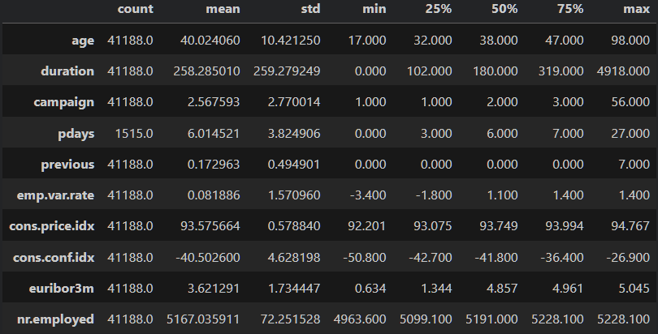

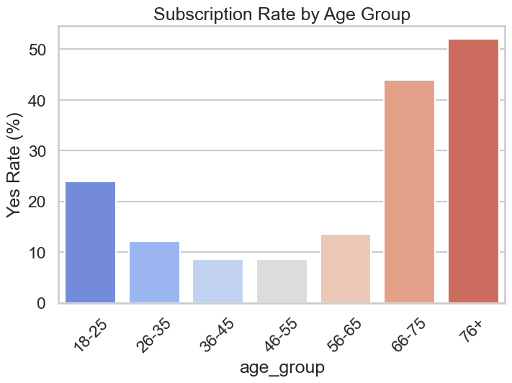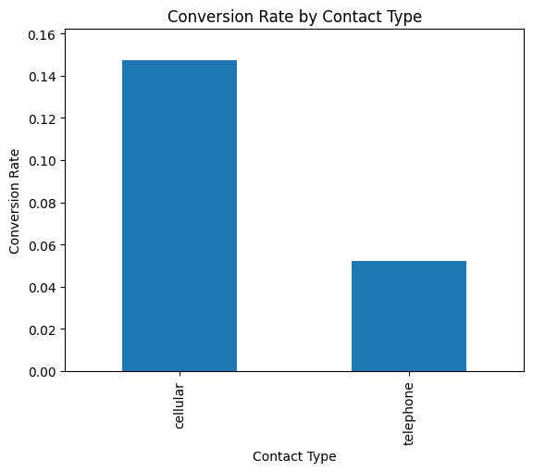
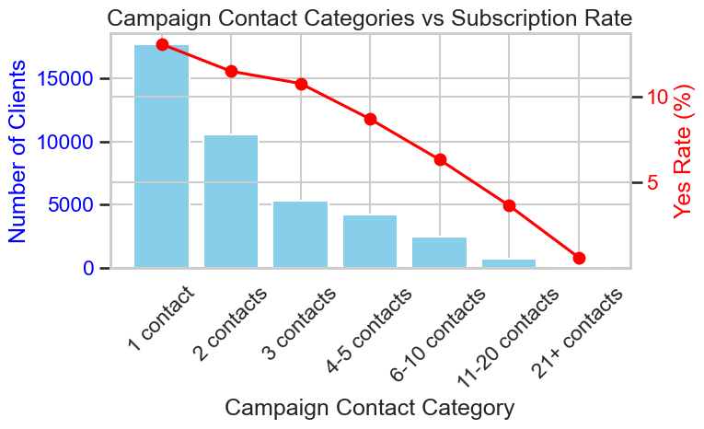
Data Preprocessing

We didn't have to do significant data preprocessing. The dataset itself was very clean without any missing values. For certain tasks we did turn numerical data into ordinal data, (e.g. age categories in exploratory data analysis.) but generally the data was very easy for us to work with.

Classification Problems

Discussion

Limitations

A meaningful limitation for our group was not knowing which outcomes would be ideal for the bank. We generally stuck with recall in our models as we imagined that the bank would rather have their marketing team not miss out on any potential clients. But it would be a strong argument that precision could also be desirable for the bank and its employees, as many of them could be working for an hourly wage and the number of calls could be very limited. In this case, a reevaluation of the modelling techniques would be necessary to optimally calculate precision.

Future Work

For our user interface, we focused on making a very functional program for employees. However, it could definitely be improved by automatically inputting the economic data instead of having the employee manually do it each time. We could also connect the program directly to the banks client database. This would prevent the employee from having to input any data. They could simply sort the clients by which one is most likely to convert, and call the clients in that order.

What We Learned

We worked with a dataset with substantial macro-economic data. This data proved to be very important in knowing whether a client would subscribe to a term deposit. While it was very helpful for modelling, a case could be made that some of this data is not controlled by the bank, and might not be useful if the bank always had the same number of employees calling clients. For example, if interest rates are very low, clients are less likely to subscribe, but the bank would still be calling their clients.

We did take some time to consider the bank's perspective and learned about how this data could still be very useful to the bank. For example, we first dismissed the macro economic data because the bank can't change the economic conditions around them, or substantially increase interest rates when it doesn't make sense. But by looking at the macro-economic data the bank could also potentially optimize their marketing costs during specific economic conditions. When interest rates are higher and clients are more likely to subscribe, they could employ more telemarketers to capitalize on these conditions and maximize profits. This is one example of where the bank can use the data to be more efficient in more ways than just targeting clients by their age or profession.

